







UID /admin/

ReadySetResource.com

Contents

12.1 - Dashboard 3

12.2 - User Management 4

12.3 - Reported Issues 5

12.4 - Business Management 6

12.4 - UID /admin/ Work Log 7

# 12.1 - Dashboard

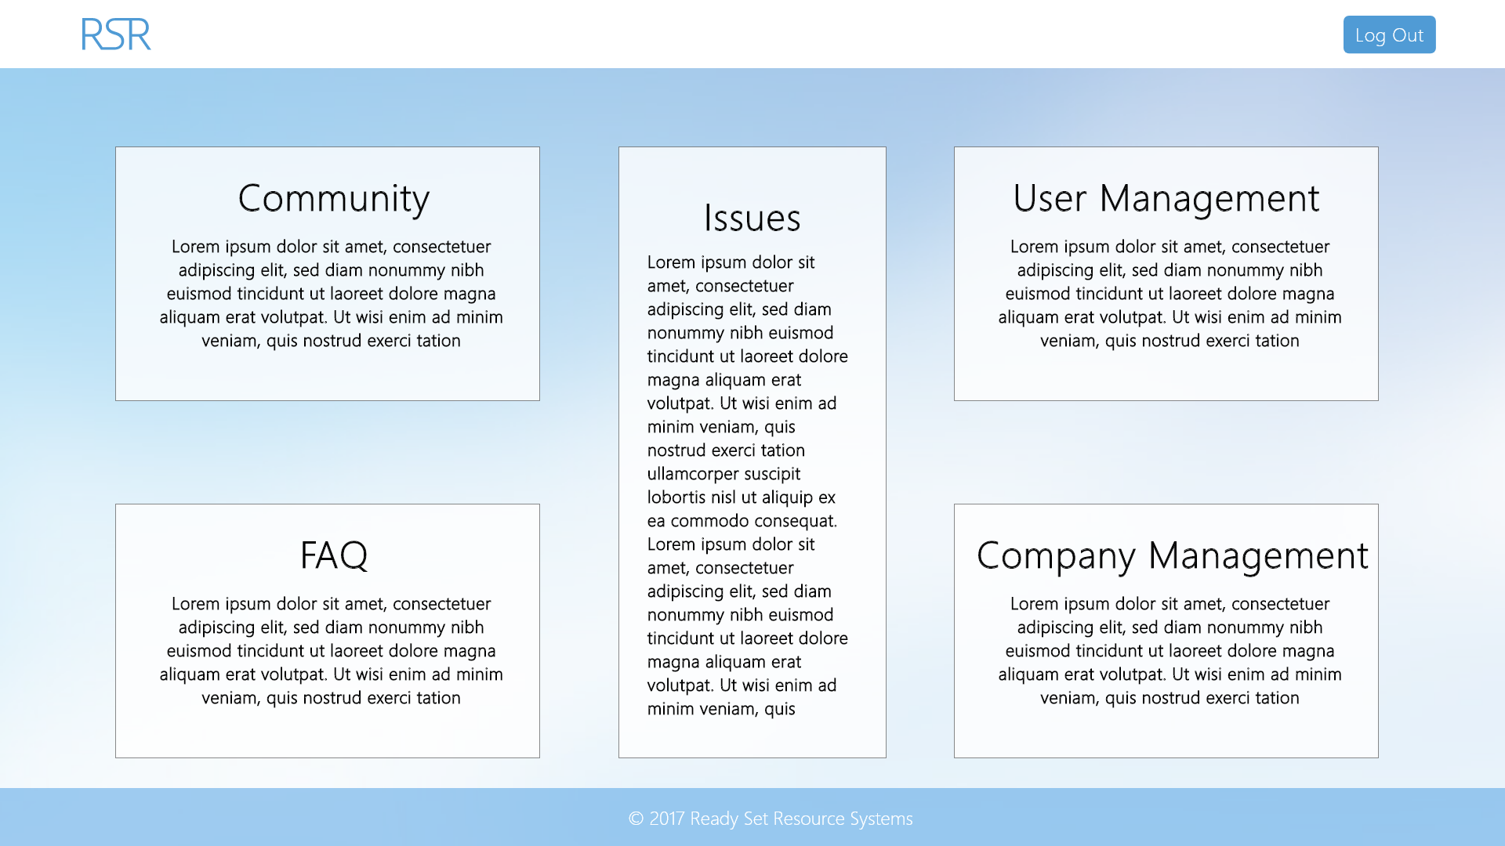

Input Permissible: None

Error Messages: None

# 12.2 - User Management

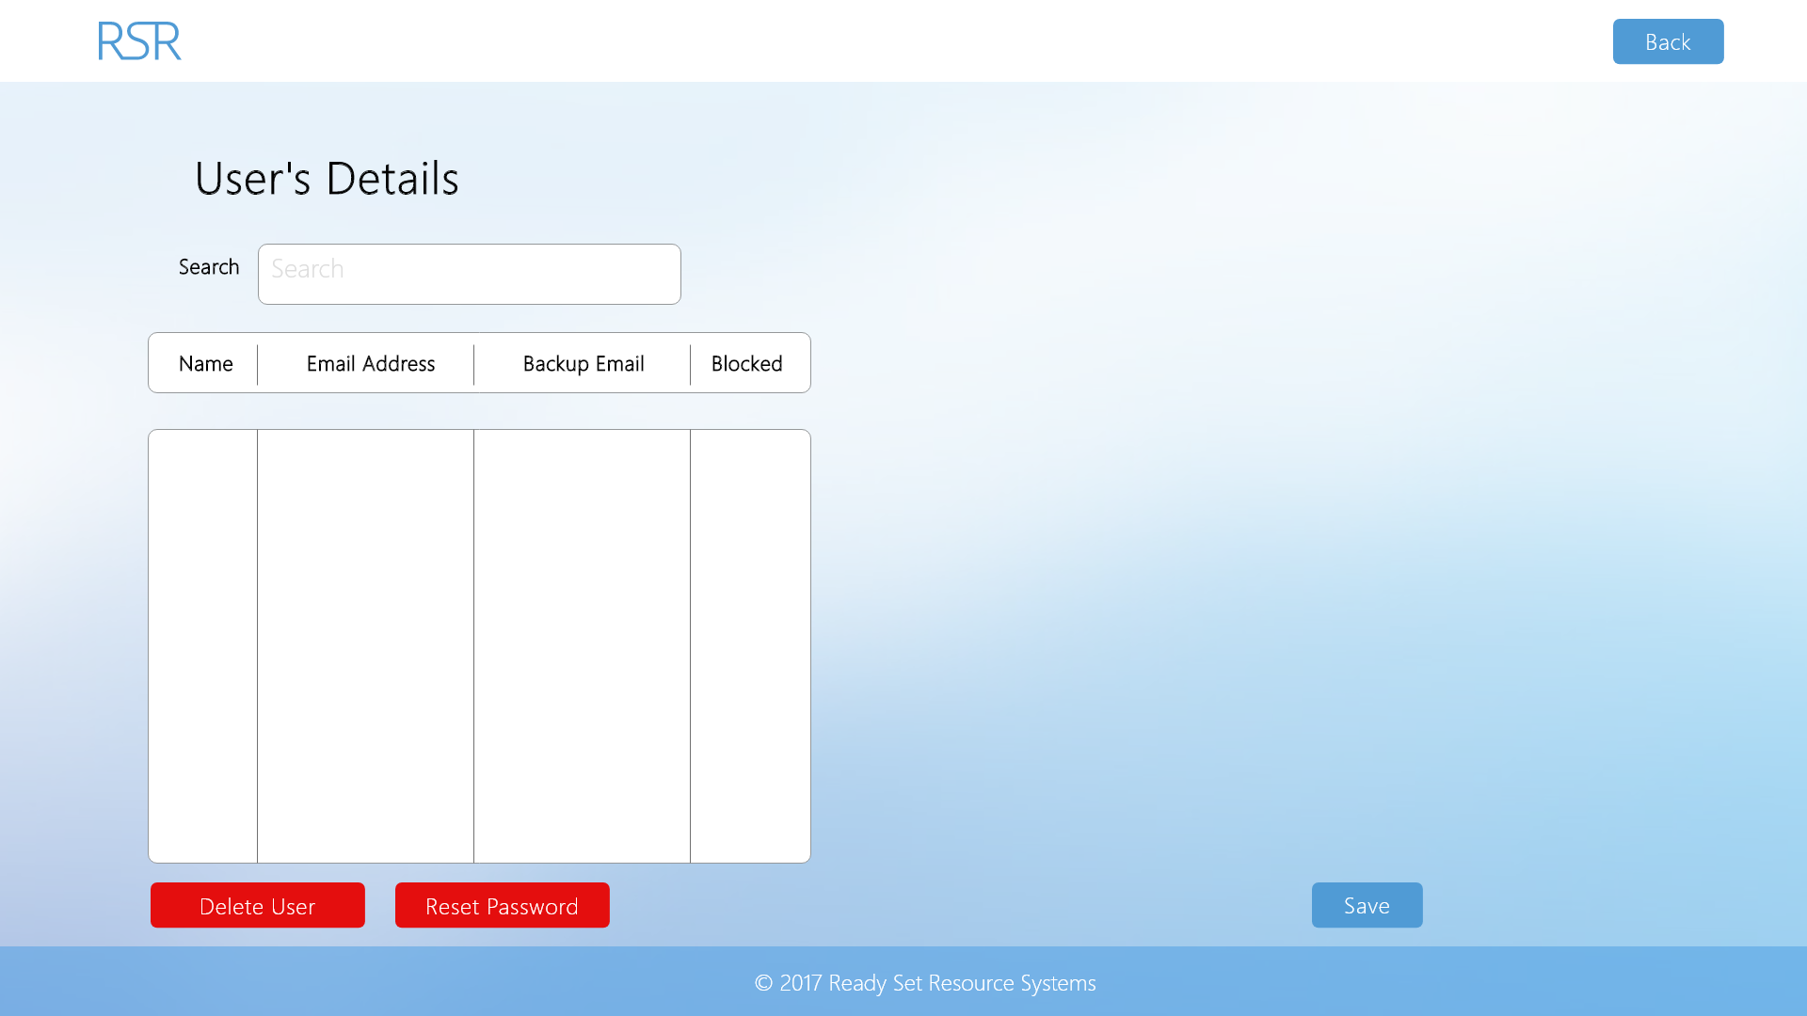

Input Permissible: - Search String

- Name

- Email Address

- Backup Email

- Blocked

Error Messages: - ‘Invalid characters’

- ‘Field cannot be left blank’

- ‘The email address you modified is incorrectly formatted’

- ‘Field too long (max 60 char.)’

# 12.3 - Reported Issues

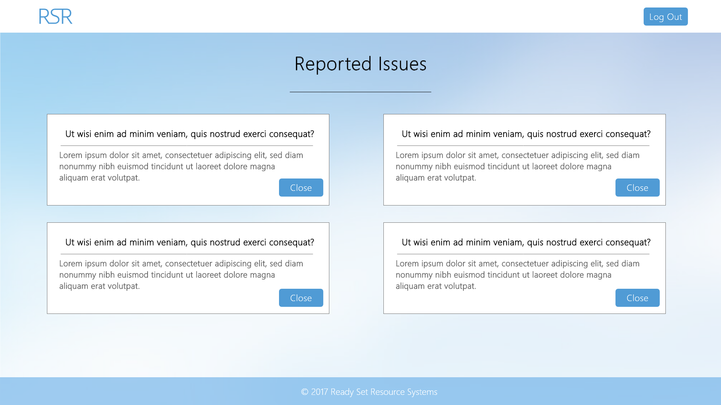

Input Permissible: - Issue closed

Error Messages: None

# 12.4 - Business Management

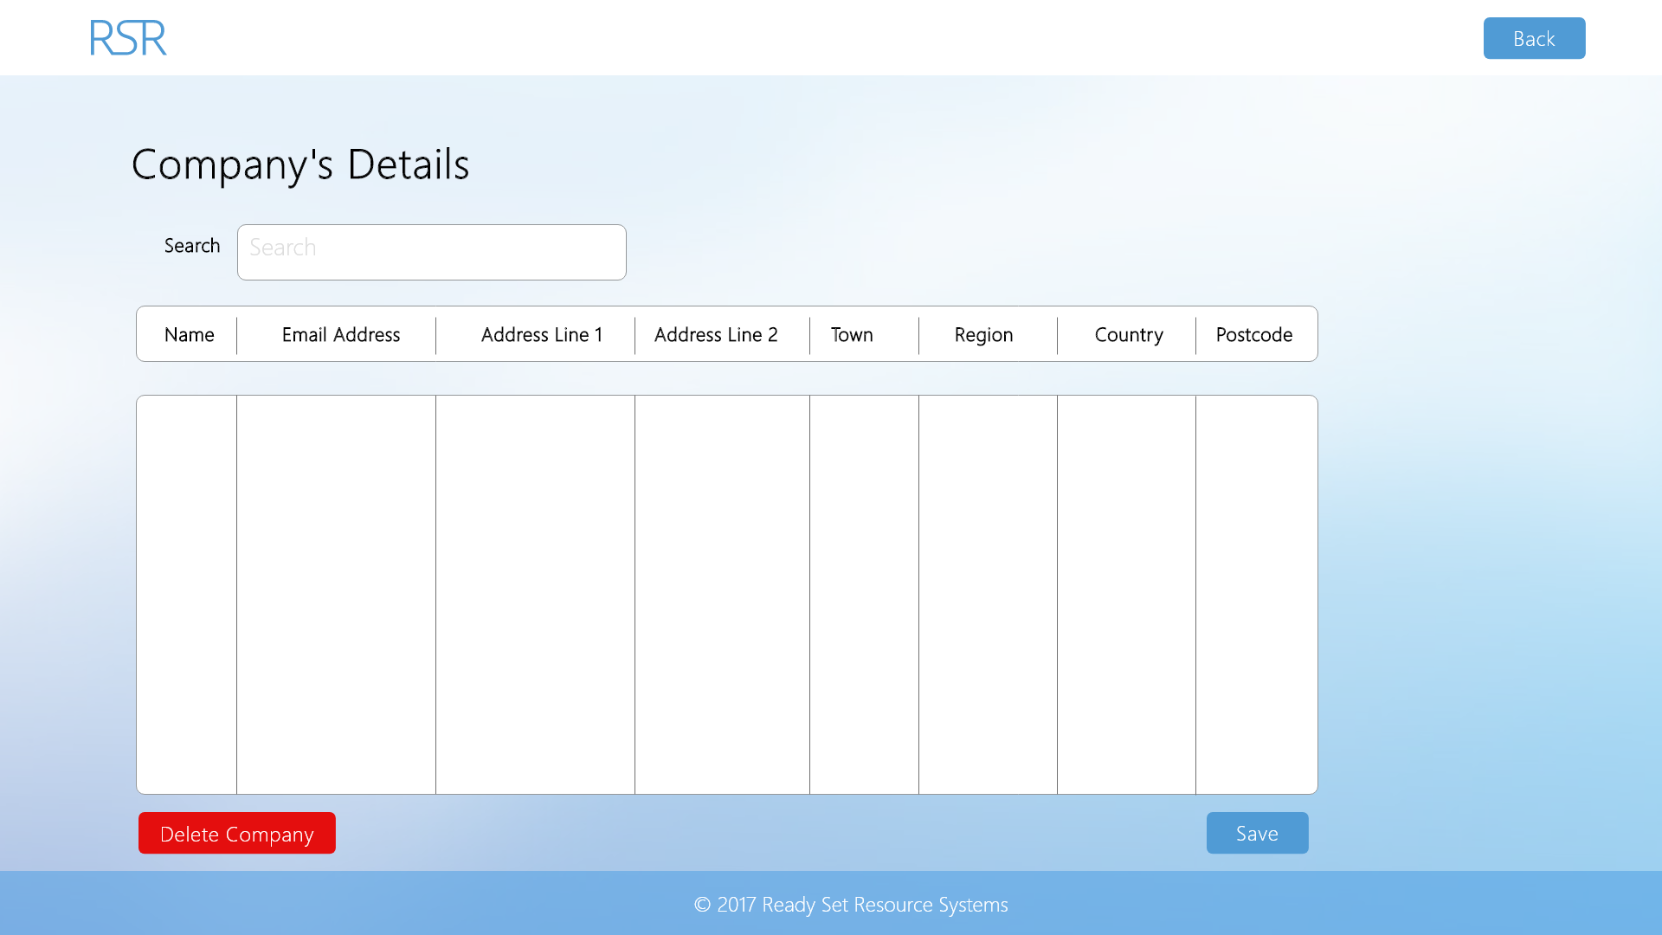

Input Permissible: - Search String

- Name

- Email Address

- Address Line 1

- Address Line 2

- Town

- Region

- Country

- Postcode

Error Messages: - ‘Invalid characters’

- ‘The email address you modified is incorrectly formatted’

- ‘Field too long’

- ‘Field cannot be left blank’

- ‘Postcode wrongly formatted’

# 12.4 - UID /admin/ Work Log

| Entry | Description | Person | Date | Mins Spent |
| --- | --- | --- | --- | --- |
| 1 | Formatted the document | Aidan Marshall | 19/3/18 | 6 |
| 2 | Designed the website | Aidan Marshall | 7/10/17 | 89 |
| 3 | Added screenshots and page details | Aidan Marshall | 7/10/17 | 12 |
| 107 | | | | |